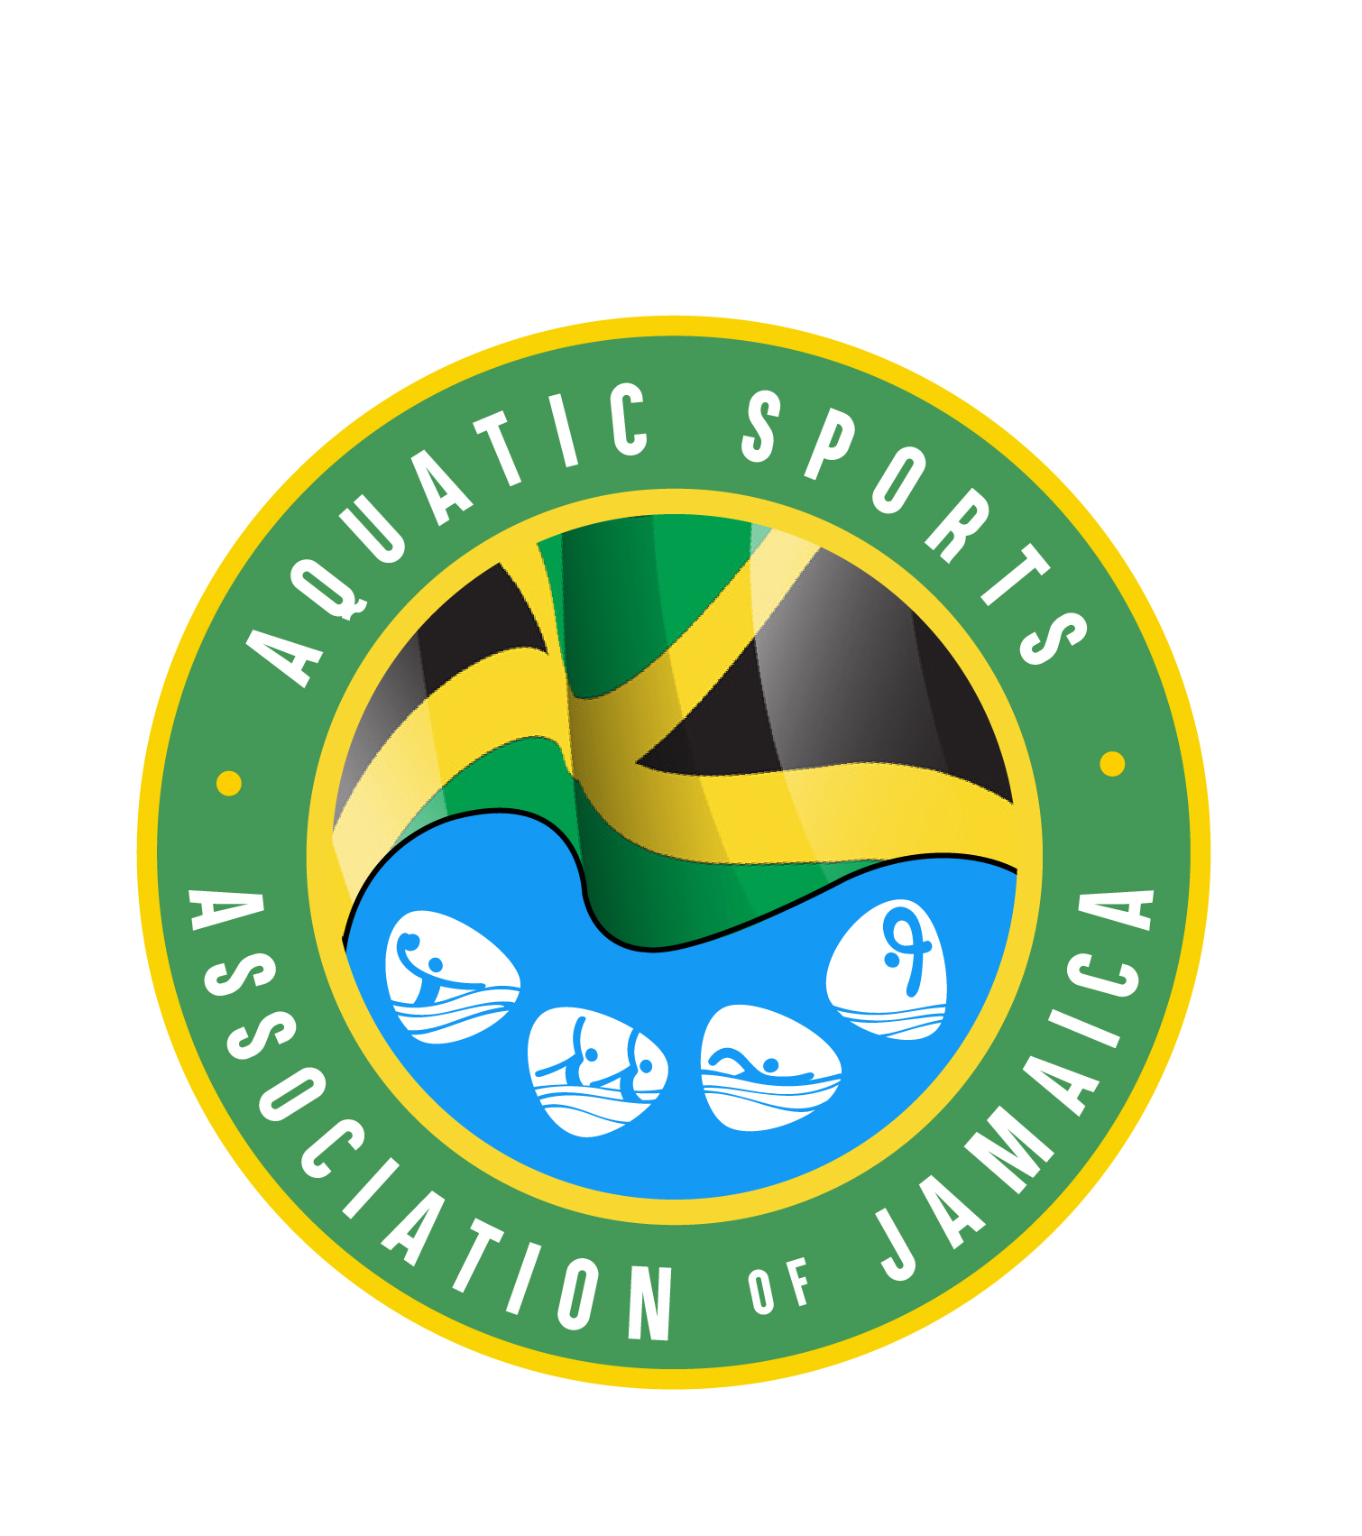

AQUATIC SPORTS ASSOCIATION OF JAMAICA
MEMORANDUM

TO: All Club Presidents, Club Representatives to Council, Swimmers and Unattached Swimmers, Water Polo Players, and Artistic Swimming Athletes.

FROM: Carol Roslyn Cuffley - Office Administrator

SUBJECT: ASAJ Club Registration and ASAJ Member Registration Fees for Calendar Year 2024

DATE: December 20, 2023

This is a reminder that Club Renewal Registration Fees and ASAJ Member Registration Fees for calendar year 2024 for all categories of membership will again become due effective January 1, 2024.

The current fee structure is as follows:
- Registration of a New Club - $5,000.00 per Club
- Annual Renewal Club Registration - $3,000.00 per Club

ASAJ Membership Fees:

- New Registration - $2,500.00 per individual

N. B. All Member Registration Forms for new members MUST be accompanied by a currently dated Government issued Proof of Age Document – e.g., Passport, Birth Certificate, Drivers Licence or National Identification Card.

- Annual Renewal Member Registration Fee Structure is as detailed below: -

- There is a special “Early Bird” Renewal Registration Fee of $1,700.00 applicable for all members of the ASAJ, once the Fee is paid on or before January 31st each year.

- If this Fee is paid on February 1st or after, the regular ASAJ Member Registration Fee of $2,500.00 will be charged and will apply to both existing members and new members.

- If the Registration Fee is paid on or after September 1st each year, there will be a pro-rated Member Registration Fee of $1,500.00 charged and this will apply to ALL categories of membership.

- Annual Coaches Fee

The Annual Registration Fee for ALL Coaches of all the aquatic disciplines is $10,000.00 per Coach.

To be eligible to receive your ASAJ Coaches Identification Card all Coaches should provide copies of a currently dated Lifeguard Certificate and NEPA License and a currently dated Police Record at the time of the renewal of their Registration. A copy of each Coaches Coaching Certification should also be submitted at the time of registration for all those Coaches for whom we do not have any Coaching Certification information on file.

- Annual Registration Fee for Technical Officials

The Annual Registration Fee for all Technical Officials of all the aquatic disciplines is Five Hundred Dollars ($500.00) per Official.

Please note however that if any Technical Official will be participating in any of the competitions under the aegis of the ASAJ, they will be required to register as an athlete as well and will therefore be required to pay the regular ASAJ Membership Fee of $1,700.00 or $2,500.00 depending on when the payment is being made.

- ASAJ Registration for the ‘Y’ Speedos Swim Club - 2024 Karl Dalhouse Memorial Invitational Swim Meet

Please be advised that the ASAJ Member, Coaches and Club Register for the 2024 Y Speedos Karl Dalhouse Swim Meet will close on Friday, January 12, 2024, at 4:00 p.m. Therefore, all individuals and Clubs wishing to participate in the Meet MUST be fully registered on or before January 12, 2024.

- ASAJ Registration for the Artistic Swimming’s “Splasquatics international Invitational

This is a reminder to all Artistic Swimmers that to be eligible to participate in this competition, all athletes MUST be registered with Island Aquatics Synchro. Club on or before January 9, 2024

- ASAJ Registration for Calendar Year 2024.

Please find attached a copy of the ASAJ Member Registration Form for Calendar Year 2024 which must be submitted when making payment. Also attached is a Registration Form which can be used to enter all the names of members of your respective Clubs who are to be registered for the New Year 2024.

Kindly note however that Registration and payment is preferred through the respective Clubs making Third Party Bank Transfers to credit the ASAJ’s Checking Account and forwarding a copy of the Receipt to aquaticsja.acc@gmail.com with a copy to aquaticsja@gmail.com for our records.

The Banking Information is as follows: -

The National Commercial Bank Jamaica Limited
1-7 Knutsford Boulevard
Kingston 5
Jamaica

For Credit to Checking Account No. 35-104-413-6 in the name of Aquatic Sports Association of Jamaica (ASAJ).

It is also being suggested that each Club should ideally identify a representative to assume responsibility for matters relating to Club Registration so that the Club will always be aware of which athletes have been registered ahead of each deadline for the various Meets.

Please be guided accordingly and share the information with the members of your respective Clubs to ensure that everyone is fully aware of the closing date for Registration for the first Swim Meet on the 2024 ASAJ calendar.

Thanks,
AQUATIC SPORTS ASSOCIATION OF JAMAICA

Carol Roslyn Cuffley, (Miss)
Office Administrator

